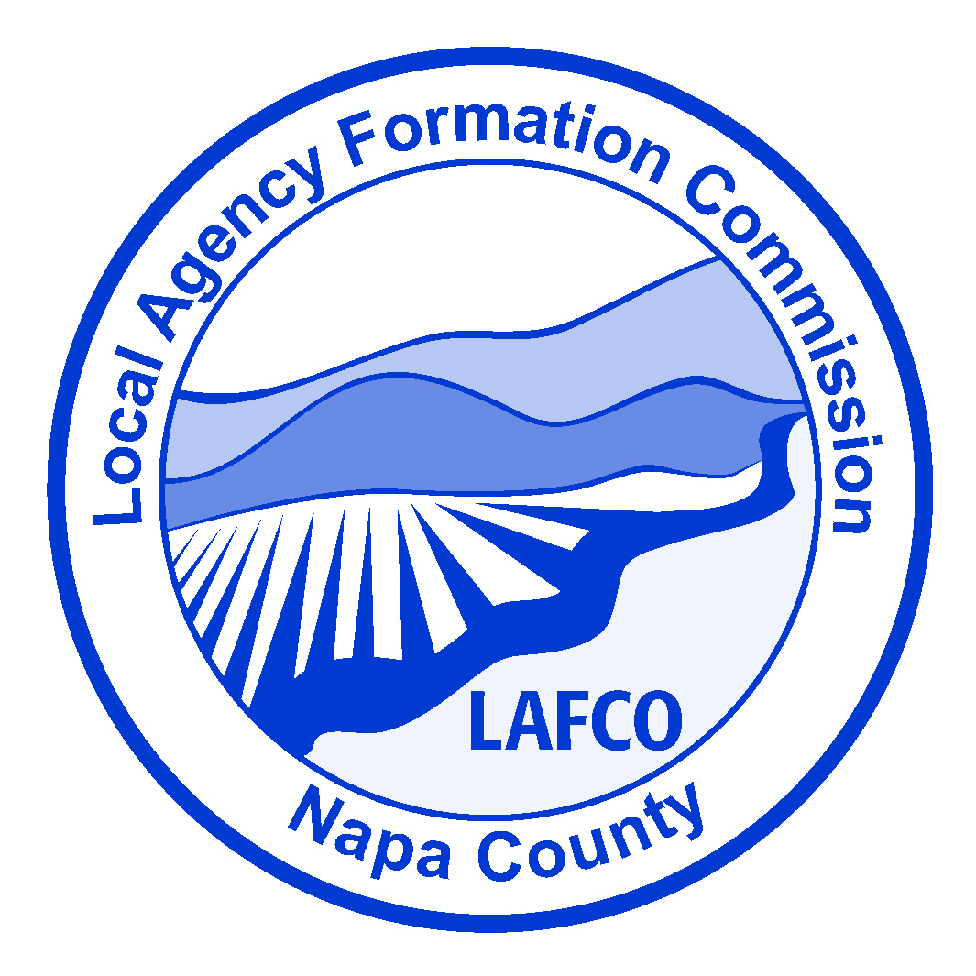

REGULAR MEETING NOTICE OF CANCELLATION

Monday, December, 2025, 3:00PM
Town of Yountville City Hall
6550 Yount Street
Yountville, California 94559

Please note the Cancellation of Napa LAFCO’s December 8th Regular Commission Meeting and the scheduled date of our February meeting below.

Thank you.

NEXT SCHEDULED MEETING
Monday, February 2, 2026, at 2:00 P.M. at the Napa County Board of Supervisors Chambers, located at 1195 Third Street, 3rd floor, Napa, CA 94559.

